Southwest Seating Interface.
Detailed photo of cam set up.
Stainless steel cam on inside.
Small spring dowl inserted through hole on side of cam to attach to pivot tube (Aluminium 5/8”) Pilot hole will need to be made once cams are in position.
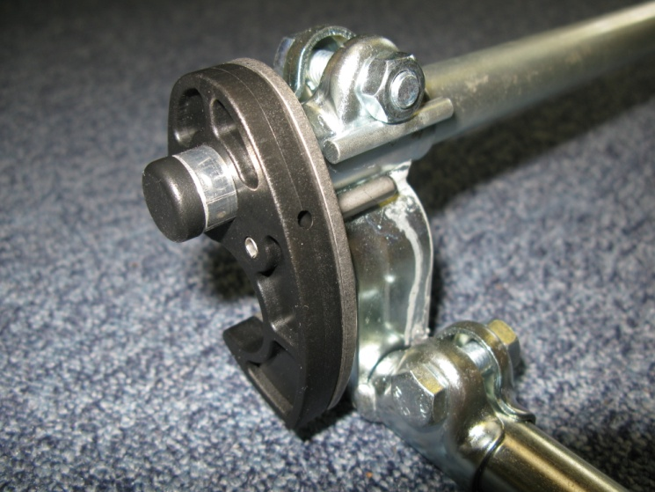

Large spring dowls are used to join plastic & stainless steel cams and to stop cams rotating, but there must also be enough movement to ensure cams can lock onto seat rail.

Cross tubes ¾” x 20” should be cut to length to ensure pivot tubes are directly above seat rails.

Clip lugs are supplied to fit to the seat rails of the wheelbase to ensure the interface does not move forward or back.

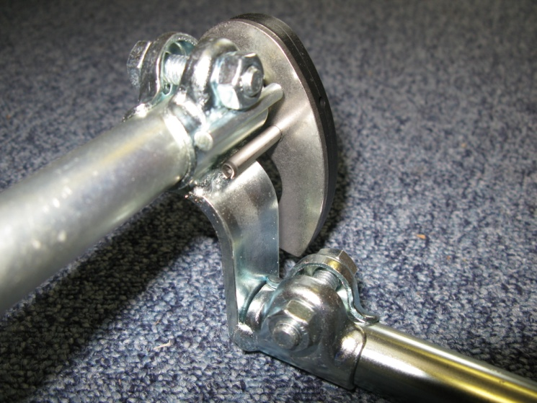

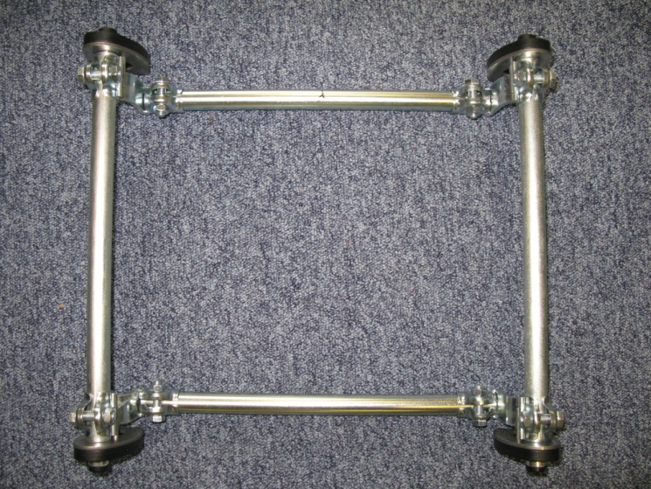
Southwest Seating & Rehab 2010.

